RFM Report User Manual

Contents

Introduction 1

System Requirements 1

Software Requirements 2

Provided Files 2

Using RFM Report 2

Phase 1: Clean and prepare data using SQL 2

Phase 2: Performing Data transformation with python 5

Phase 3: Performing RFM analysis and generating reports in Power BI 7

Phase 4: Identify cut off percentiles 8

Phase 5: Second stage data preparation 9

Phase 6: Performing RFM analysis and generating reports in Power BI 11

Report Interpretation Guide: Kunnithi 13

Page 1: RFM 2D Distribution and Population 13

Page 2: RFM 3D Distribution and Centroids 16

Page 3: RFM 3D Distribution and Centroids 17

Page 4: Outlier Overview 19

Page 5: RFM segment popularity and average M per segment 20

Report Interpretation Guide: Likhit 21

Page 1: Overview of Customer Segmentation using RFM Analysis 21

Page 2: Customer Segmentation by Brand 24

Page 3: Customer segment change from 2021-2022 to 2022-2023 25

Page 4: 2021-2022 vs 2022-2023 27

# Introduction

This comprehensive guide is designed to walk you through the process of configuring RFM reports for insightful customer segmentation analysis. Utilizing RFM (Recency, Frequency, and Monetary) analysis, this manual will provide you with a step-by-step approach to harnessing the power of RFM to gain valuable insights into your customer base.

# System Requirements

Before operating this report, please ensure that your computer meets the following requirements:

* Windows system or OS that supports Power BI Desktop
* Connectivity to CRM database server
* Efficient SQL and Power BI performance
* Sufficient storage capacity for storing exported CSV file
* Internet connection

# Software Requirements

* Database management tool (e.g. DBeaver)
* Power BI Desktop or Power BI Pro License
* Custom visuals in Power BI: Chord
* VS Code or alternative Python IDE
* Python

# Provided Files

* SQL script
* Data preparation python code
* Power BI template
* Data dictionary
* User manual

# Using RFM Report

## Phase 1: Clean and prepare data using SQL

1. Open database management tool
2. Connect to database

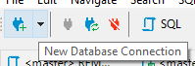

1. Open provided SQL code “RFM_first_stage.sql”: File -> Open File…

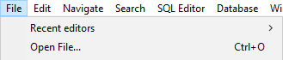

1. Change date range in line 23, line 42 (Select the date after maximum date selected in line 23), for line 86 and 105 change the range to past year to compare with current year.









1. Run all query: Ctrl + A (Select all) -> Ctrl/Cmd + Enter (Execute query)

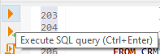

Disclaimer: this process may take several minutes, do not interrupt while the program is querying

1. Close all result tabs

* By right clicking on “Results” and click “Close All Tabs” to reduce confusions

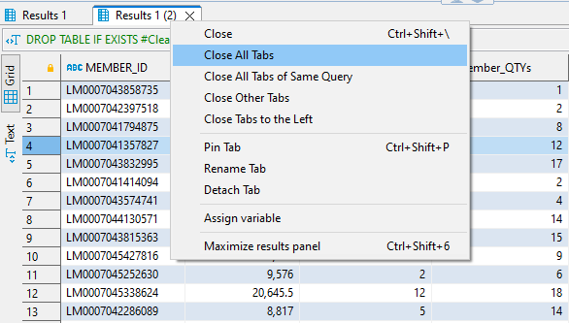

1. Execute line 130



1. Export data



* Export target: CSV -> Next
* Extraction settings -> Next
* Format settings -> Next
* Output: select your preferred directory
  + Set File name pattern as _Temp_Member_Metrics

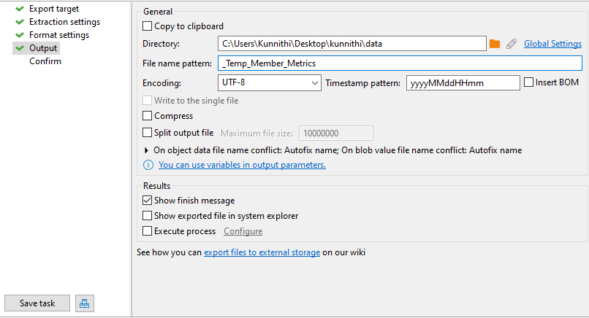

* + Next
* Confirm -> Proceed

1. Execute line 131



1. Export data

* Export target: CSV -> Next
* Extraction settings -> Next
* Format settings -> Next
* Output: select your preferred directory
  + Set File name pattern as _Temp_Member_Metrics_Previous

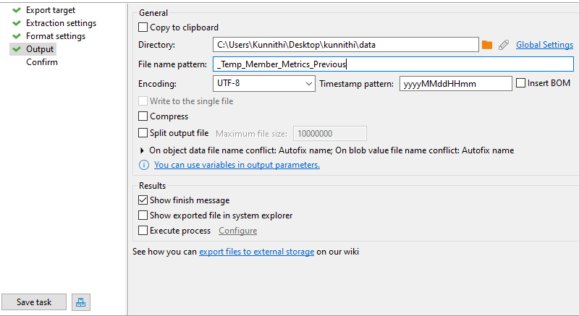

* + Next
* Confirm -> Proceed

1. Rename the files

* Expected result

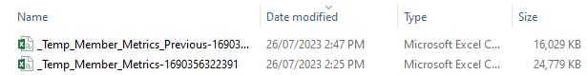

* Rename the files by deleted anything start from – to the end

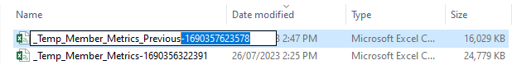

* The final result

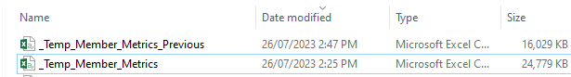

## Phase 2: Performing Data transformation with python

1. Open “data_preparation.ipynb” with Visual Studio Code



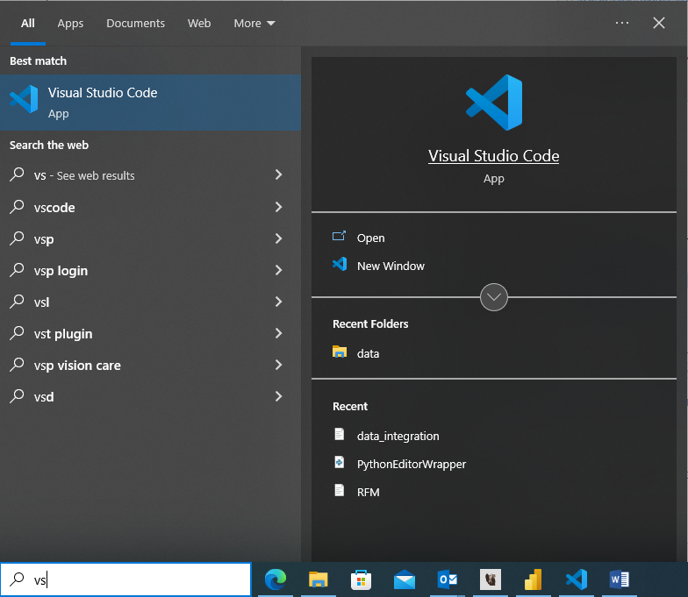

* Noted that there are 3 files must be in the same folder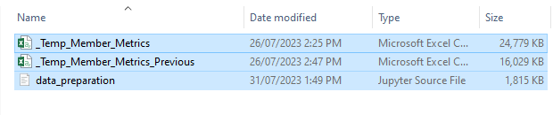

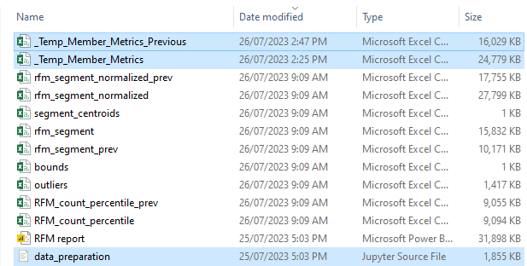

1. Run the code

* First, try to find **“Restart”** if you able to see it, if you can’t find it that’s means everything is all set. click it and confirm to restart, it will delete all variable from previous use. By doing this it will prevent Bug happened.
* Click the **“Run All”** button, this will take several minutes to run depends on size of data, approximately 20 min

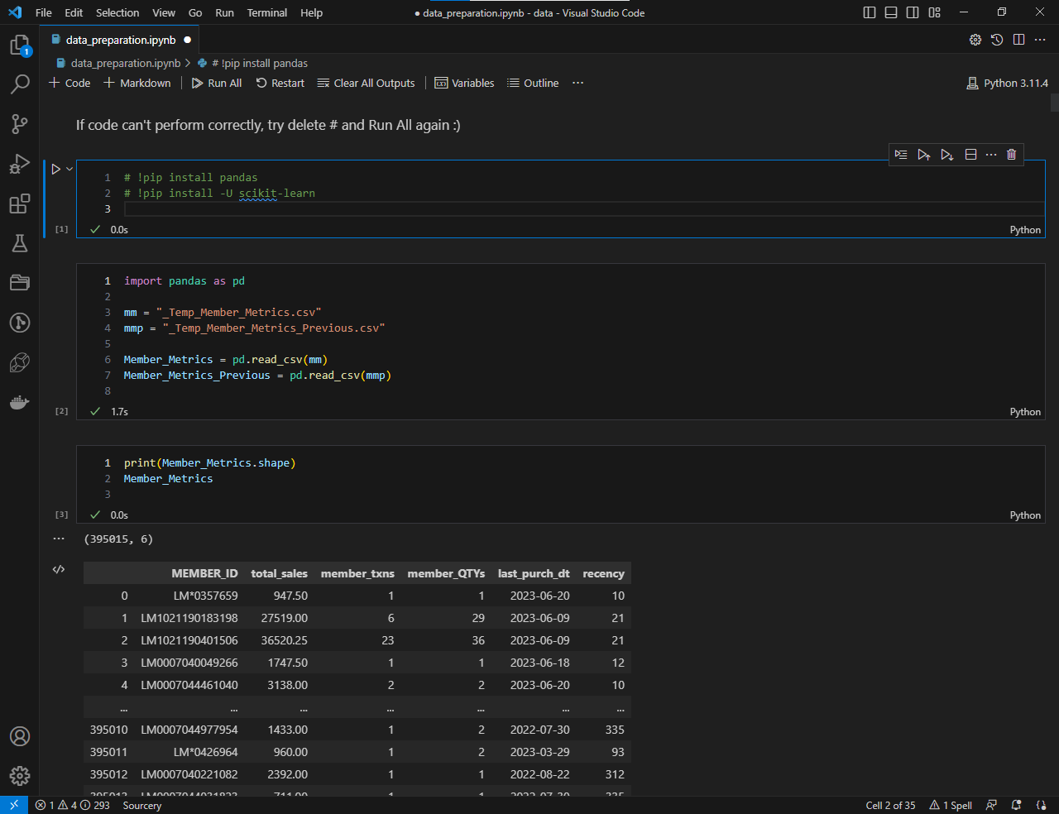

* Expected result

You can see the circle sign over here, it’s appear when the code is running and disappear after all code is executed, that’s means data for PowerBI is ready to use.



The files created by this code is these 9 files

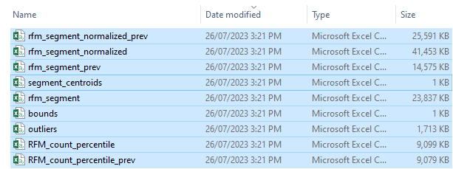

**Note:** If you are normal user that doesn’t have knowledge about data analyst you can continue the next phase, if not, you can keep scroll down to see some insight of the data ex structure of data, some visualization, informative variable such as skewness or cut off percentile and algorithm to auto select cut off percentile

Only 1 thing normal user can make change to the code is percentile cut off, but I not recommend to do it, because algorithm to select percentile cut off is available in the code. If you really need to change it replace variable with the number Ex. Change upper bound of R to 95% what you need to do is fill it with 0.95

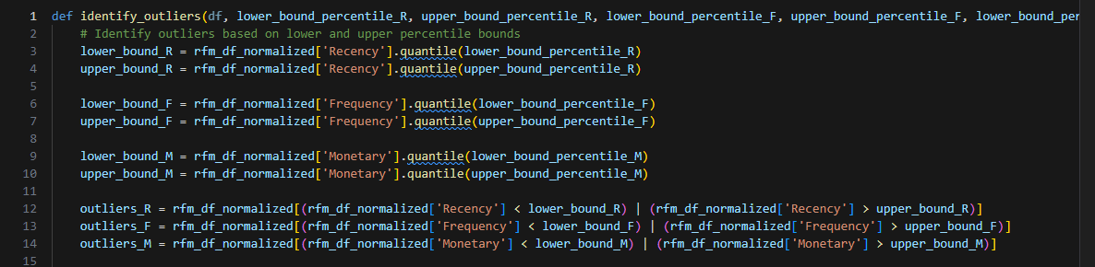

## Phase 3: Performing RFM analysis and generating reports in Power BI

1. Open Power BI Desktop
2. Open template

* File -> Import -> Power BI template -> Open the report template from your saved location (file name is RFM report) 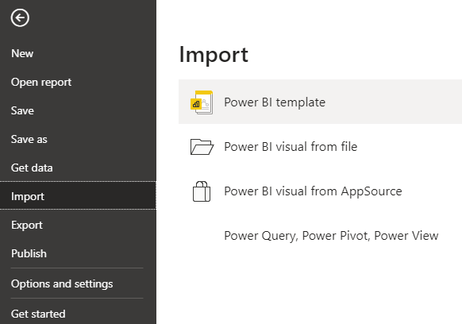

1. Refresh data

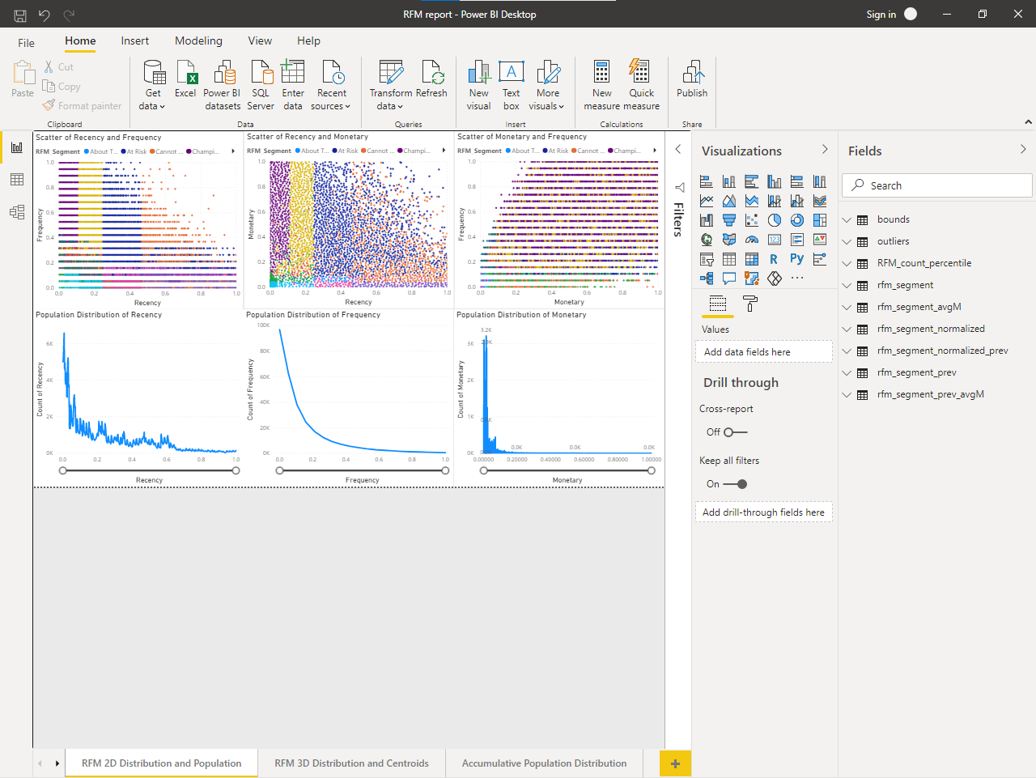

## Phase 4: Identify cut off percentiles

1. Go to Outlier Overview page (4th page), then you will be able to see all percentile cut off

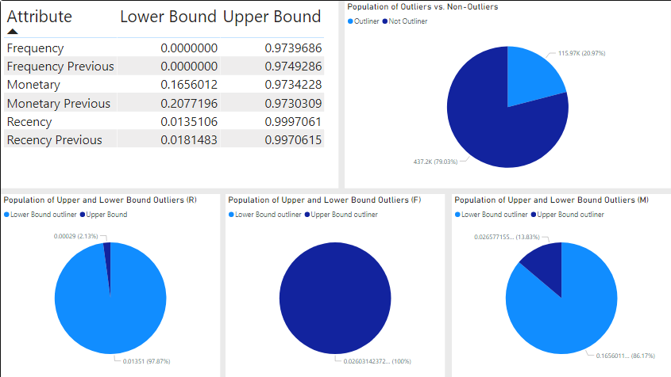

1. Apply it to Likhit’s SQL

## Phase 5: Second stage data preparation

1. Open database management tool
2. Connect to database



1. Open provided SQL code “RFM_second_stage.sql”: File -> Open File…



1. Change date range in line 22 & line 212





1. Change the date in line 49 & line 203 to the date after maximum date selected in 4.





1. Apply the lower bound cutoff percentile from Phase 4 by modifying lines 107-109 in the following order: recency, frequency, and monetary



1. Apply the upper bound cutoff percentile from Phase 4 by modifying lines 88-90 in the following order: recency, frequency, and monetary



1. Execute all queries: Ctrl + A (Select all) -> Ctrl/Cmd + Enter (Execute query)



Disclaimer: this process may take several minutes, do not interrupt while the program is querying

1. Execute line 168-170: the dataset that will be utilized to generate an overview of customer segmentation
2. Export data



* Export target: CSV -> Next
* Extraction settings -> Next
* Format settings -> Next
* Output: select your preferred directory
  + Set File name pattern as RFM_pg1_MMMMYY-YY e.g. RFM_pg1_June21-22

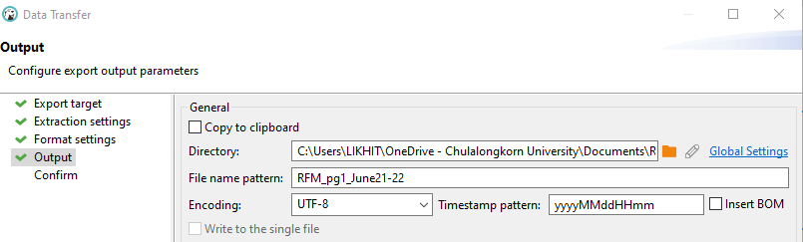

* + Next
* Confirm -> Proceed

1. Execute line 229-232: the dataset that will be utilized to generate brand-level customer segmentation
2. Export data

* Export target: CSV -> Next
* Extraction settings -> Next
* Format settings -> Next
* Output: select your preferred directory
  + Set File name pattern as RFM_pg2_MMMMYY-YY

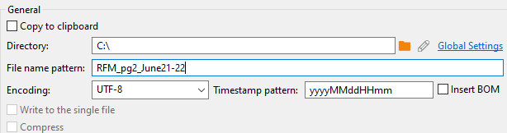

* + Next
* Confirm -> Proceed

1. Repeat step 1-9 for year range before selected year e.g. July 2022-2023 -> July 2021-2022 for reports on the third and fourth page.

Disclaimer: 4 tables will be exported

## Phase 6: Performing RFM analysis and generating reports in Power BI

1. Open Power BI Desktop
2. Open template

* File -> Import -> Power BI template -> Open the report template from your saved location

1. Update tables

Queries -> Transform data -> Data source settings -> Select a table from the list -> Change Source… -> Choose an exported table with names related to the one selected earlier e.g. replace RFM_pg1_June22-23 with RFM_pg1_July22-23

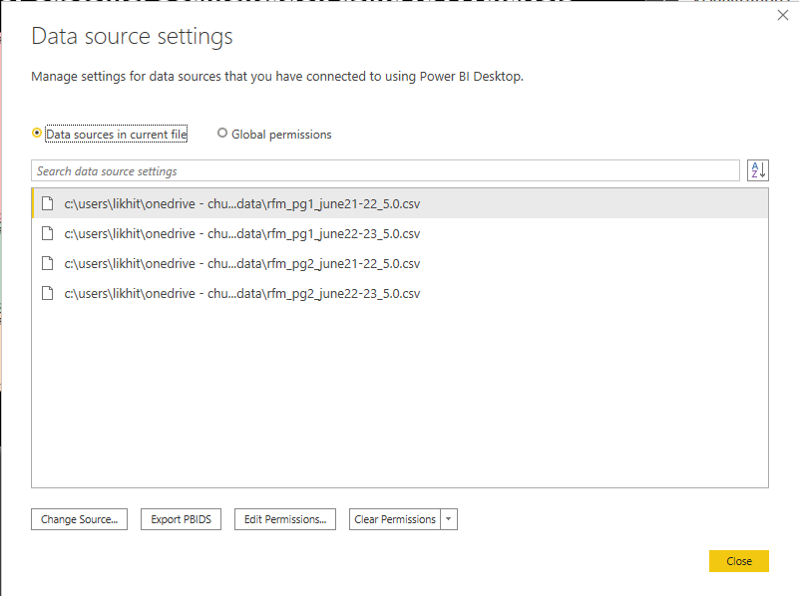

1. Repeat step 3 for every table listed in the data sources
2. Update “refDate”: Use the maximum date in the table + 1 as value in “refDate”

* Fields -> Measures -> “refDate”

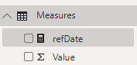

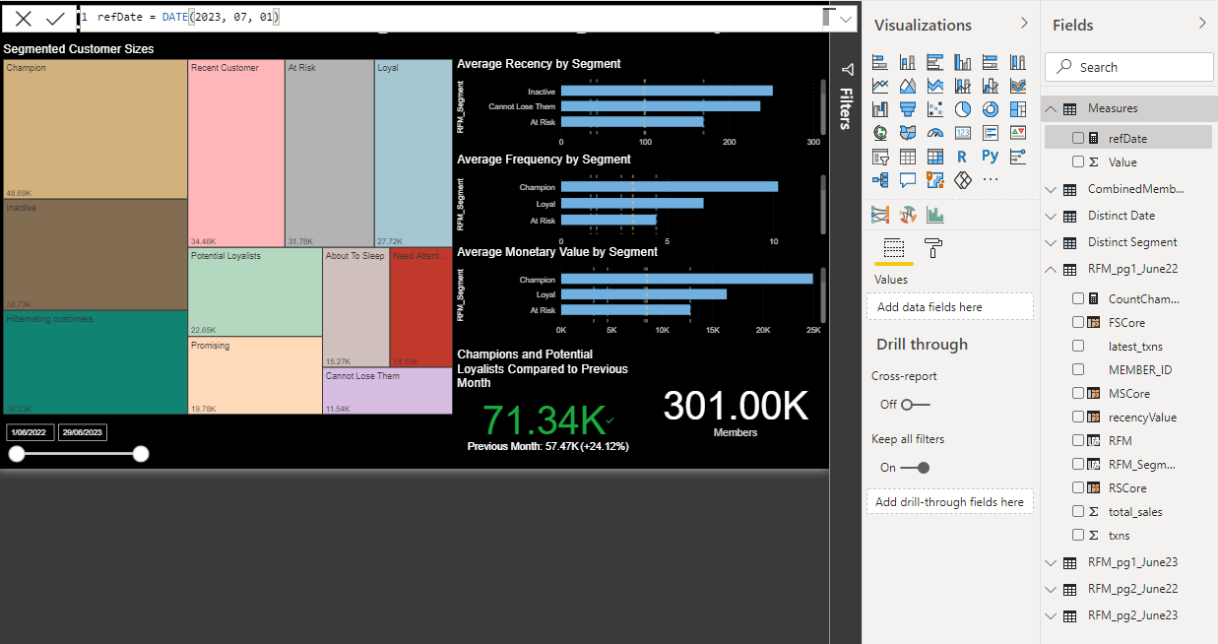

* Standard analytics: Change date in DAX bar. For example, maximum date in the table = 30-06-2023, then set the date in “refDate” as 01-07-2023 -> DATE(2023,07,01) ; same date as in line 50 step 4 in Phase 1
* Custom analytics: Users have the flexibility to manually adjust the "refDate" to their preferred date for analysis. For instance, they can set the "refDate" as 01-06-2023 (DATE(2023, 06, 01)), which allows them to perform RFM analysis using data where the latest transaction date of customers falls between the minimum date in the dataset and 30-05-2023. This allows users to explore specific time periods of interest and gain insights accordingly.
* Changing “refDate” will automatically affect every imported tables

Disclaimer: Please be advised that, due to current limitations in the software, the process of updating the "refDate" value cannot be automated. As a result, users will be required to manually change the "refDate" value each time the data range needs to be updated.

# Report Interpretation Guide: Kunnithi

## Page 1: RFM 2D Distribution and Population

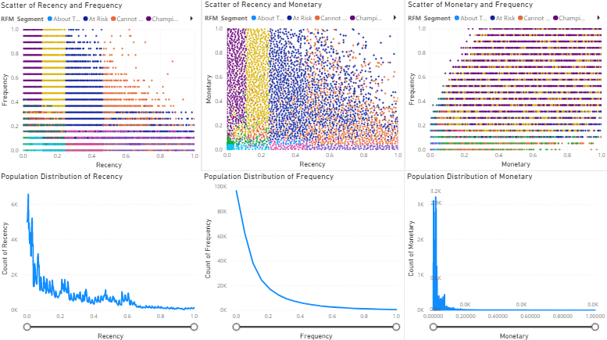

The dashboard aims to analyze and visualize key relationships and distributions within the dataset related to recency, frequency, and monetary value. It provides insights into customer behavior, engagement, and spending patterns, enabling data-driven decision-making. The scatter plots (Recency vs. Frequency, Monetary vs. Frequency, and Recency vs. Monetary Value) offer a comprehensive view of the correlations between these metrics. Additionally, the population distribution line charts (Recency, Frequency, and Monetary) present an overview of the concentration of individuals within specific ranges, allowing for better understanding and

|  |  |
| --- | --- |
| Recency vs. Frequency (Scatter Plot) | scatter plot that is useful for selecting a cutoff point to eliminate outliers. By examining the scatter plot, you can identify any data points that exhibit unusual or extreme values in terms of their Recency, Frequency and Monetary Value. These outliers may represent customers with atypical purchasing behaviors or spending amounts. By establishing a cutoff point, you can determine which data points to consider as outliers and potentially exclude them to ensure the analysis focuses on more typical customer |
| Monetary vs. Frequency (Scatter Plot) |
| Recency vs. Monetary Value (Scatter Plot) |
| Population Distribution of Recency (Line chart) | Line chart illustrates the distribution of the population based on their normalized recency values, ranging from 0 to 1. The X-axis represents the normalized recency, indicating how recently individuals have engaged in certain activities or events, with 0 being the least recent and 1 being the most recent. The Y-axis displays the count of people falling within each recency category. |
| Population Distribution of Frequency (Line chart) | In this Line chart, the population is analyzed based on their normalized frequency of occurrences, varying from 0 to 1. The X-axis depicts the normalized frequency values, indicating how often individuals engage in specific events or activities, with 0 representing the lowest frequency and 1 indicating the highest frequency. The Y-axis shows the count of people corresponding to each frequency category. |
| Population Distribution of Monetary (Line chart) | Line chart presents the population distribution concerning their normalized monetary behavior, ranging from 0 to 1. The X-axis represents the normalized monetary values, which highlight the spending patterns or financial activities of individuals within the specified range, where 0 signifies the lowest monetary activity and 1 denotes the highest. The Y-axis denotes the count of people associated with each monetary category. |

interpretation of customer segments and trends.

There are Zoom slider in 3 bottom chart to select the scope of R or F or M normalized value

## Page 2: RFM 3D Distribution and Centroids

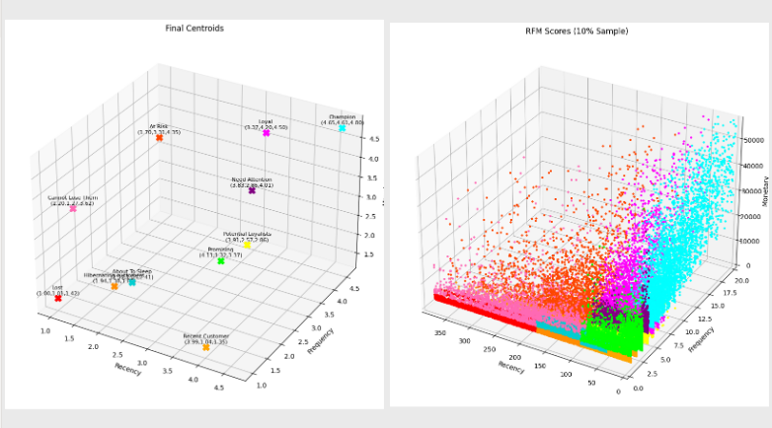

This dashboard visualizes the relationships between different RFM dimensions (R, F, and M) using scatter plots. It includes scatter plots of R vs. F, M vs. F, and R vs. M, highlighting the correlations between these variables. It also features a 3D scatter plot showcasing the relationship among R, F, and M. Lastly, it presents a 3D scatter plot displaying the centroids of each RFM segment for a comprehensive understanding of segment characteristics.

|  |  |
| --- | --- |
| Centroid of Each RFM Segment (3D Scatter Plot) | visualizing the distinct clusters formed by different RFM segments. The centroids represent the scores values (1-5) of Recency, Frequency, and Monetary Value for each segment, providing insights into the typical behaviors and characteristics of customers within each segment. |
| Recency vs. Frequency vs. Monetary (3D Scatter Plot) | scatter plot is useful for selecting a cutoff point to eliminate outliers. By examining the scatter plot, you can identify any data points that exhibit unusual or extreme values in terms of their Recency, Frequency and Monetary Value. These outliers may represent customers with atypical purchasing behaviors or spending amounts. By establishing a cutoff point, you can determine which data points to consider as outliers and potentially exclude them to ensure the analysis focuses on more typical customer |

## Page 3: RFM 3D Distribution and Centroids

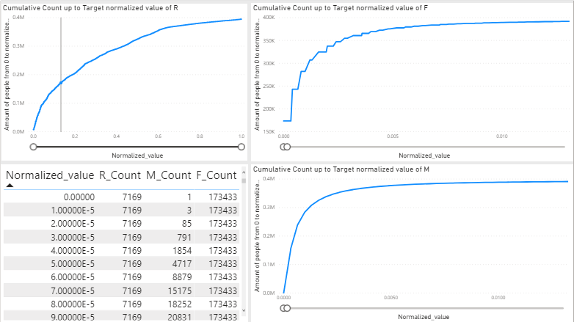

Dashboard illustrate how the population count progressively increases as the target value rises from 0 to a specific value. The graph plots the cumulative count of individuals, representing the number of people falling within or below each target value, on the Y-axis against the corresponding target value on the X-axis. By observing the upward trend in the graph, users can identify the cutoff point for outliers, helping them gain insights into the overall population distribution and make informed decisions regarding extreme data points.

|  |  |
| --- | --- |
| Cumulative Count up to Target normalized value of R (Line chart) | Line graph that illustrates the progressive accumulation of counts as the normalized values of "R" increase from 0 to the target value. The X-axis represents the normalized values of R or F or M while the Y-axis displays the cumulative count of occurrences at each corresponding normalized value. This chart provides valuable insights into the trend and density of occurrences related to the specific metric or variable R or F or M helping identify critical thresholds and cutoff percentile for outliner |
| Cumulative Count up to Target normalized value of F (Line chart) |
| Cumulative Count up to Target normalized value of M (Line chart) |
| Table of normalized value and cumulative count of R, F and M (Table) | Table that provide a comprehensive view of how the population count accumulates within the range from 0 up to a specific target value. By plotting the sum of people count on the Y-axis against the target value on the X-axis, the graph shows the cumulative number of individuals falling within or below each target value. |

There are 3 Zoom slider that use to select the scope of R or F or M normalized value, normally cut off point can be select by analyse these graph for lower bound select where the slope of line is high and for upper bound select where the slope start to stable ex 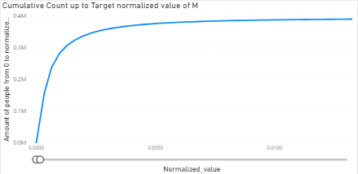 

Then when you click the point in line chart the table will show the percentile of the point you select

## Page 4: Outlier Overview

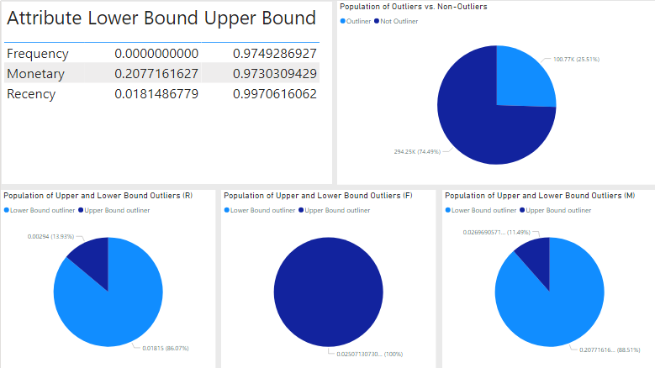

The dashboard aims to provide a comprehensive overview of the population distribution, specifically focusing on outliers and the upper and lower bounds of three metrics: Recency (R), Frequency (F), and Monetary Value (M). The visual representations aid in understanding the composition of various segments within the dataset and enable data-driven decision-making, such as targeted marketing strategies or identifying high-value customers.

|  |  |
| --- | --- |
| Table of cutouff percentile (Table) | show cuttoff percentile of R, F, M value |
| Population of Outliers vs. Non-Outliers (Pie chart) | pie chart presents the distribution of the population into two segments: outliers and non-outliers. Outliers are data points that significantly deviate from the majority of observations, while non-outliers represent the more typical data points. This chart helps understand the extent of extreme observations within the dataset. |
| Population of Upper and Lower Bound Outliers (R) (Pie chart) | illustrates the distribution of individuals categorized as either upper bound outliers or lower bound outliers in the Recency (R) metric. |
| Population of Upper and Lower Bound Outliers (F) (Pie chart) | displays the proportion of individuals classified as either upper bound outliers or lower bound outliers in the Frequency (F) metric. |
| Population of Upper and Lower Bound Outliers (M) (Pie chart) | showcases the distribution of individuals identified as either upper bound outliers or lower bound outliers in the Monetary Value (M) metric. |

## Page 5: RFM segment popularity and average M per segment

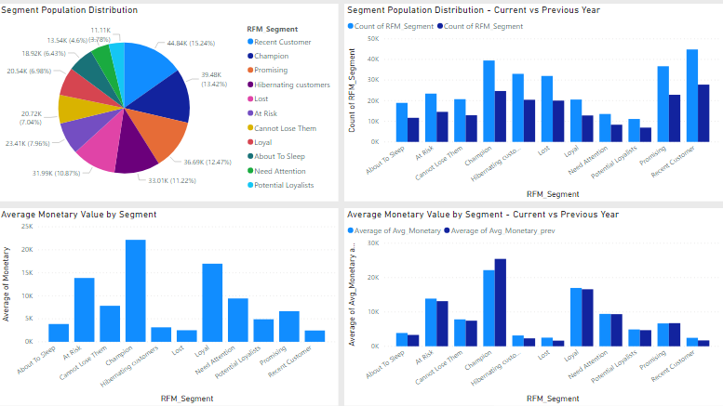

The objective of this dashboard is to provide a comprehensive analysis of population segmentation based on outliers and the upper and lower bounds of three metrics: Recency (R), Frequency (F), and Monetary Value (M). The dashboard utilizes four different charts to visualize and compare key insights.

|  |  |
| --- | --- |
| Segment Population Distribution (Pie chart) | Pie chart displays the distribution of the population across various segments. Each segment represents a specific grouping based on certain metrics or criteria. The chart allows for an intuitive understanding of the proportion of individuals in each segment, providing insights into the size and composition of the different segments |
| Segment Population Distribution - Current vs Previous Year (Cluster bar chart) | cluster bar chart that compares the population distribution of each segment between the current year and the previous year. It provides two sets of bars side-by-side for each segment, one representing the population count in the current year and the other representing the population count in the previous year. This chart helps identify any shifts or changes in the distribution of the population across segments, facilitating trend analysis and understanding segment growth or decline. |
| Average Monetary Value by Segment (Bar chart) | bar chart showcases the average monetary value in each segment. By presenting the average monetary value on the Y-axis and segment labels on the X-axis, this chart enables a comparison of spending patterns or behaviors between the segments. |
| Average Monetary Value by Segment - Current vs Previous Year (Cluster bar chart) | cluster bar chart comparing the average monetary value of each segment between the current year and the previous year. Similar to the previous chart, it presents two sets of bars for each segment, representing the average monetary value in the current year and the average monetary value in the previous year. This chart helps identify changes in spending patterns or customer behavior across segments over time. |

# Report Interpretation Guide: Likhit

## Page 1: Overview of Customer Segmentation using RFM Analysis

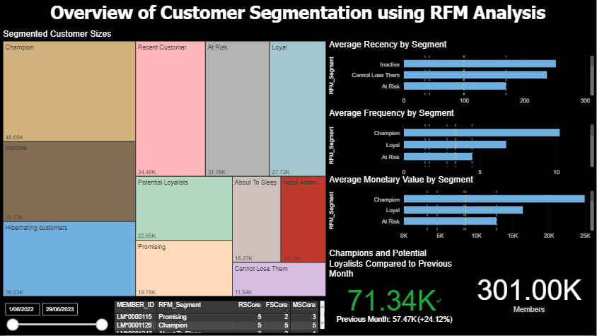

This page of the report provides valuable insights into customer segmentation based on RFM scores. Users can quickly identify different customer segments, understand their distribution, and observe the average Recency, Frequency, and Monetary values for each segment.

1. **Segmented Customer Sizes**

This treemap provides an insightful representation of customer segmentation based on the calculated R, F, and M scores derived from recency, frequency, and monetary values. Each segment is color-coded, allowing for easy visual identification. The size of each segment in the treemap corresponds to the number of members falling into that particular segment.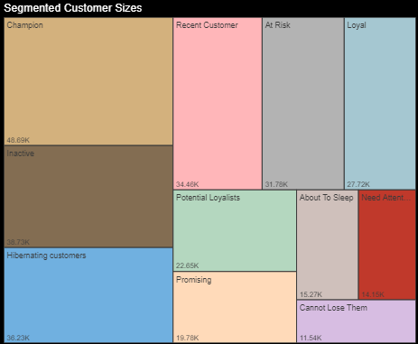

|  |  |
| --- | --- |
| **Customer Segment** | **RFM Scores** |
| Champion | 555, 554, 544, 545, 454, 455, 445, 543 |
| Loyal | 444, 435, 355, 354, 345, 344, 335 |
| Potential Loyalists | 553, 551, 552, 541, 542, 533, 532, 531, 452, 451, 442, 441, 431, 453, 433, 432, 423, 353, 352, 351, 342, 341, 333, 323 |
| Recent Customer | 512, 511, 422, 421, 412, 411, 311 |
| Promising | 525, 524, 523, 522, 521, 515, 514, 513, 425, 424, 413, 414, 415, 315, 314, 313 |
| Need Attention | 535, 534, 443, 434, 343, 334, 325, 324, 331, 321, 312, 221, 213, 231, 241, 251 |
| At Risk | 255, 254, 245, 244, 253, 252, 243, 242, 235, 234, 225, 224, 153, 152, 145, 143, 142, 135, 134, 133, 125, 124 |
| Cannot Lose Them | 155, 154, 144, 214, 215, 115, 114, 113 |
| Hibernating customers | 332, 322, 233, 232, 223, 222, 212, 211, 115, 114, 113 |
| About to Sleep | 331, 321, 312, 221, 213, 231, 241, 251 |
| Inactive | All other RFM scores not listed in the previous segments |

* Users can interact with the treemap by hovering over each segment, revealing the total number of members within that specific segment. Additionally, for easier readability, the total numbers are presented in the bottom left corner of each segment, rounded to the nearest thousand.

1. **Average recency, frequency, and monetary value bar graph by segment**

These horizontal bar graphs provide a visual depiction of the average recency, frequency, and monetary values for each customer segment. Users can conveniently scroll through each graph to explore segments that are not immediately visible.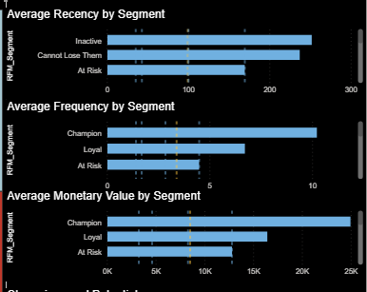

To aid in interpretation, the yellow dotted line represents the overall average recency value calculated from all segments combined. Additionally, the blue dotted lines indicate the 20th, 40th, 60th, and 80th percentiles, providing valuable insights into the distribution of values across the segments. The segments are sorted in descending order based on their respective average values.

1. **Champions and potential loyalists compared to previous month**

This KPI facilitates a comparison between the total number of "Champion" and "Potential Loyalists" customers up to the selected maximum month and the total count of these segments up to the month just before the chosen maximum month. By utilizing this KPI, users can effectively monitor the growth or decline of their most valuable customer segments over a specific timeframe. The number is rounded to the nearest thousand.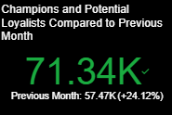

When the value is displayed in green, it indicates that the selected month has more "Champion" + "Potential Loyalists" customers compared to the preceding month. Conversely, when displayed in red, it indicates a decline in these segments.

Furthermore, the number of members in the previous month is shown in white text at the bottom, along with the percentage of growth or decline.

1. **Total members card**

This card provides a straightforward representation of the number of members that were included in the analysis.. 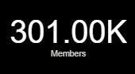

1. **Table representing each member’s R scores, F scores, M scores, and their segment**

The provided table serves as a valuable tool when users aim to delve deeper into a specific segment's characteristics and examine the individual RFM scores of each member within that segment.

Furthermore, to enhance the user experience and facilitate data analysis, the table offers the option to export the data. By simply hovering over the table, users will find an "Export Data" button, which allows them to seamlessly export the table's contents.

1. **Time slicer**

The "Time Slicer" is a feature that allows users to select a specific range for the latest transaction date. While it does not recalculate the RFM segments, it offers a valuable way to explore the customer segment calculated during the selected latest transaction date and the members falling into that specific period. This functionality is particularly useful when users want to examine the customer segment composition and characteristics at a particular point in time. User can drag or click on date to specify the date range.

With the exception of KPIs and cards, all other visualizations within the report offer interactive capabilities that significantly enhance the user experience. Users can actively engage with these visuals by interacting with them, and any changes made will dynamically impact other interconnected visualizations.

For instance, if a user clicks on the "Champion" cell in the treemap, this specific segment will be highlighted not only in the treemap itself but also in every other visualization present. This seamless interactivity allows users to gain deeper insights and conduct detailed analysis of the selected segment, making it easier to understand the segment's characteristics and behavior.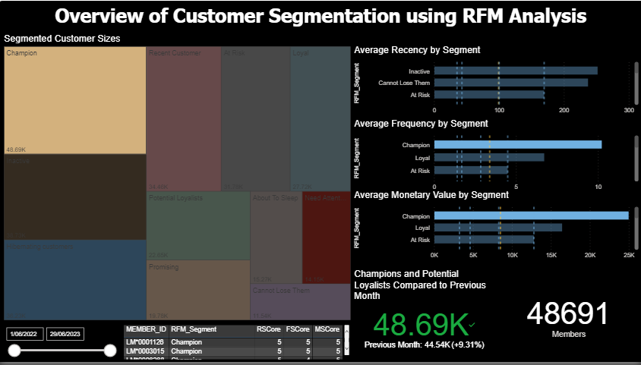

## Page 2: Customer Segmentation by Brand

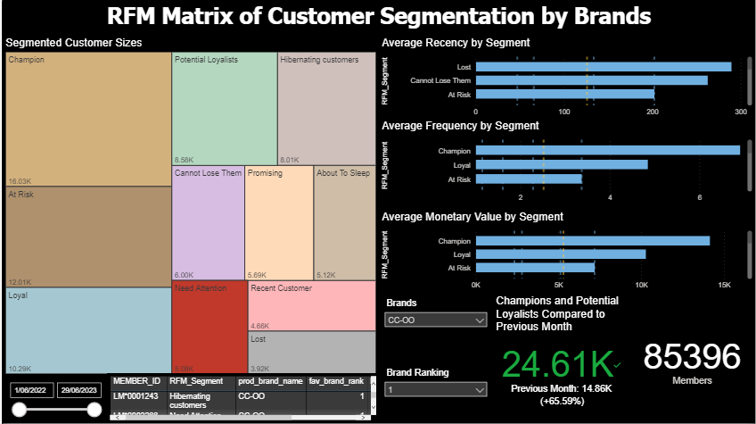

This page of the report offers insights into customer segmentation by brands, focusing on individual or multiple brand performance. Each member may have multiple rows in the table, representing their interactions with different brands. The brand ranking is determined based on the customer's most frequent, highest amount, and highest monetary value purchases. This page allows users to analyze customer behavior and preferences towards specific brands, enabling a deeper understanding of brand loyalty and engagement for more targeted marketing strategies and business decisions. Here are key differences from the first report:

1. **Brand filter**

This filter enables users to select one or more brands that customers have purchased at least once, offering valuable insights into the segmentation of specific brands' customers. Users can explore the average RFM values for the selected brand(s), view the total number of members considered in the analysis, and track the growth or decline of "Champion" + "Potential Loyalists" segments for the chosen brand(s). This feature empowers users to gain in-depth understanding of each brand's customer base and identify potential growth opportunities. User can select brand(s) by clicking on the downward icon and a dropdown list of brand names will appear.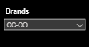

1. **Brand ranking filter**

The "Brand Ranking" filter provides users with the ability to filter rows based on specific brand rankings they choose. Users can select one or more brand rankings, and the filter will display rows where the brand ranking matches the selected ranking(s). This feature enables users to focus their analysis on particular brands with specific performance levels, such as top-performing brands (brand ranking = 1) or brands that need improvement (e.g. brand ranking = 3 or 4). By using this filter, users can gain deeper insights into how different brand rankings impact customer segmentation and behaviors.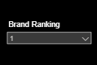

## Page 3: Customer segment change from 2021-2022 to 2022-2023

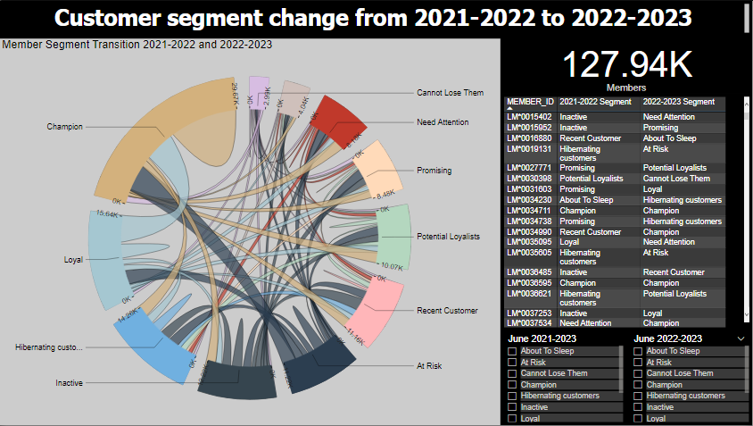

This page of the report represents the change of customer segments for members whose latest transaction date falls within both date periods. It showcases the development and evolution of these members over time. This feature provides valuable insights into how members' preferences and engagement have changed between the two selected timeframes.

1. **Chord diagram representing member segment transition**

This diagram presents a visual representation of member segment transitions during two specific timeframes. When users hover over the flow lines, the number of member transitions from one segment to another and in the reverse direction will be displayed. The width of the flow line determines the size of the transition, while the curve length of the circle corresponds to the size of each segment. To reduce complexity, each segment is represented in a different color.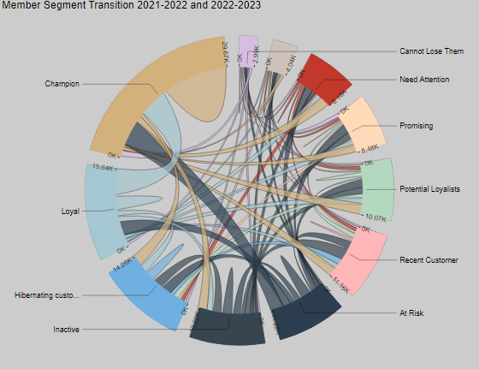

Additionally, user can click on a segment to gain insights of the transition of the member that were initially in that segment. 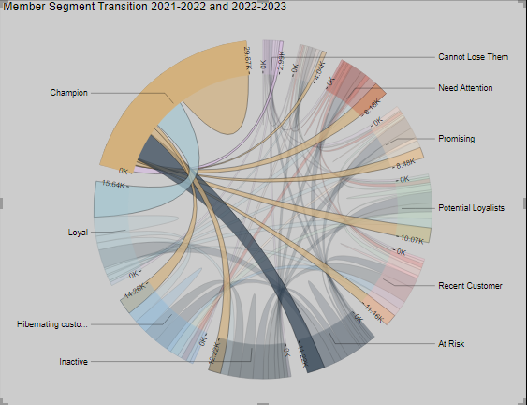

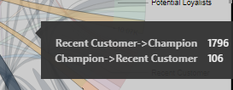

1. **Member segment filter during two timeframes**

These filters are valuable tools for analyzing specific segments. Users can utilize the table to select a segment and observe the member transitions either from or to that particular segment. Alternatively, users can specify conditions in both tables to gain insights on members that fall between those two specific conditions. These filters effectively reduce the complexity of the chord diagram, allowing users to focus on their preferred transitions and gain a deeper understanding of customer behavior patterns.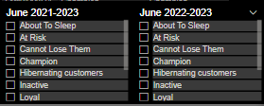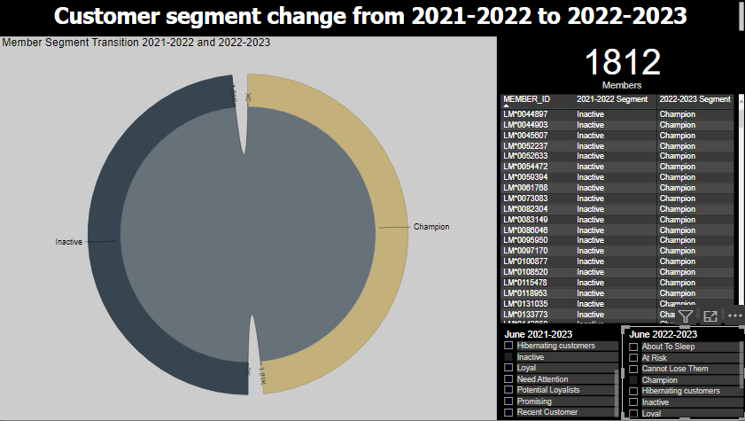

1. **Member Table**

This table provides a comprehensive view of members who fall into the category of selected conditions. Users can customize the table by choosing specific conditions to analyze, allowing them to focus on relevant segments and extract valuable insights. By clicking on the 3-dot icons located on the top right corner of the table while hovering, users can conveniently export the table data. This export functionality facilitates further data analysis and allows users to delve deeper into specific segment characteristics and behaviors outside the visualization tool.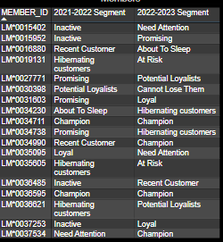

1. **Members count**

This text box displays the total number of members that meet the condition(s) selected in the filter table.

## Page 4: 2021-2022 vs 2022-2023

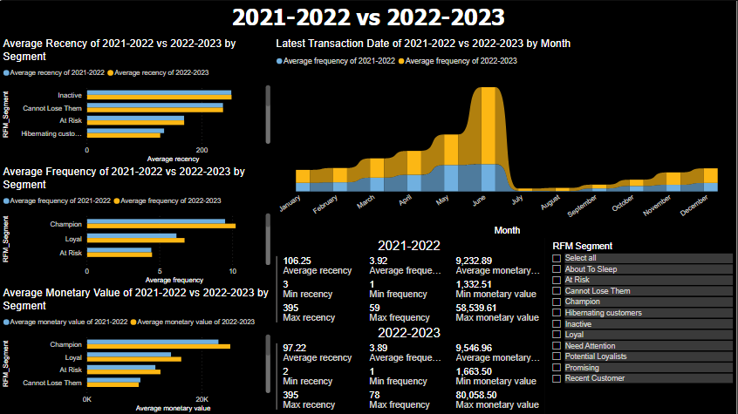

In this last page of the report, we delve into the compelling comparison of various key aspects and statistics that significantly impact the segmentation of RFM between the two time ranges.

1. **Average recency, frequency, and monetary value comparison of two time ranges by member segment**

These clustered bar charts illustrate a comparison of the average recency, frequency, and monetary value for each member segment across two distinct time frames. The charts offer a clear and insightful view of how members' spending behavior has evolved over the specified periods.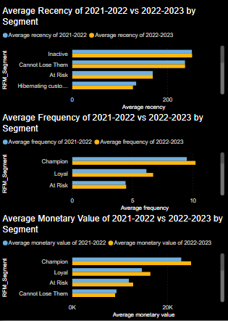

1. **Comparison of average member count based on latest transaction date, segmented by month, across two time frames**

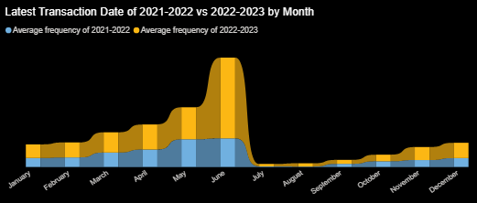

The ribbon chart displays a comparison of the average member count based on their latest transaction date, segmented by month, across two distinct time frames. The horizontal axis represents the months, while the vertical axis represents the number of members.

This visualization provides valuable insights into the fluctuation of member engagement over time, highlighting any shifts in the distribution of members across different months in the two time frames.

1. **Average, minimum, and maximum recency, frequency, and monetary value of two time frames**

These cards present key metrics, including average, minimum, and maximum values of recency, frequency, and monetary values across two distinct time frames. These numerical insights are invaluable for users seeking a clear understanding of the differences in each metric between the two periods.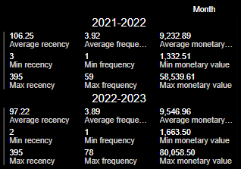

1. **Member segment filter**

This Member Segment Filter empowers users to selectively choose one or more segments, enabling them to focus on specific groups and gain tailored insights.